Parallel Interface and 8255 PPI
A Parallel Interface is used for transmitting multiple data signals simultaneously over several parallel channels. In essence, multiple bits (typically 8) are transmitted at the same time on different channels within the same cable.
They are also commonly used within ICs, peripheral buses, and memory devices like RAM.
Benefits or Advantages of Parallel Interface
The primary advantage of a parallel interface is its speed.
- It offers faster data communication between devices compared to serial interfaces.
Drawbacks or Disadvantages of Parallel Interface
Despite its speed, the parallel interface has some limitations.
- It supports short-distance communication between devices. This limitation arises from crosstalk between the parallel lines.
- It uses more wires compared to a serial interface, making it more costly and somewhat more complex to implement.

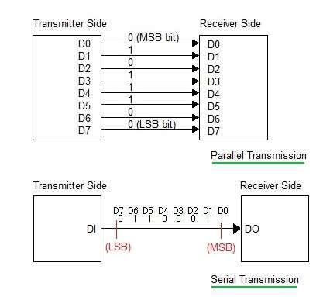

Modes of Parallel Data Transfer
i) Simple I/O
• When you need to get digital data from simple switch, such as thermostat, into microprocessor, all you have to do is connect the switch to an I/O port line and read the port.
• Likewise, when you need to output data to simple display device, such as LED, all you have to do is connect the input of the LED buffer on an output port pin and output the logical level required to turn on the light.
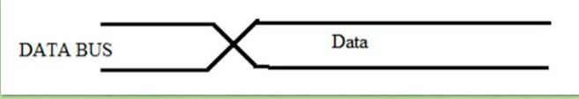
Fig: Simple I/O

iI) Strobe I/O
• In many applications, valid data is present on an external device only at a certain time, so it must be read in at that time.
• E.g. the ASCII-encoded keyboard. When a key is pressed, circuitry on the keyboard sends out the ASCII code for the pressed key on eight parallel data lines, and then sends out a strobe signal on another line to indicate that valid data is present on the eight data lines.
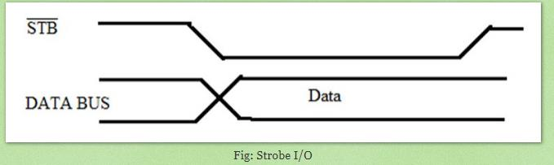

The sending device, such as a keyboard, outputs a parallel data on the data lines, and then outputs an STB signal to let you know that valid data is present.
• For low rates of data transfer, such as from a keyboard to a MP, a simple strobe transfer works well.
• However, for higher speed data transfer, this method does not work because there is no signal which tells the sending device when it is safe to send the next data byte.
• In other words, the sending system might send data bytes faster than the receiving system could read them.
• To prevent this problem, a handshake data transfer scheme is used.
iii. Single handshake
• The peripheral outputs some parallel data and sends an STB signal to the MP.
• The MP detects the asserted STB signal on a polled or interrupts basis and reads in the bytes of data.
• Then, the MP sends ACK (acknowledge) signal to the peripheral to indicate that the data has been read and that the peripheral can send next byte of data.
• The point of this method is that the sending device or system is designed so that it does not send the next byte until the receiving device or system indicates with an ACK signal that it is ready to receive the next byte.

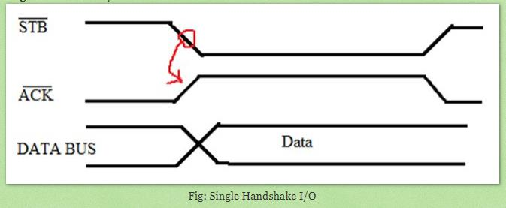

iv. Double Handshake
• For data transfer where even more coordination is required between the sending system and the receiving system, a double handshake is used.
• The sending (peripheral) device asserts its STB line low to ask the receiving device whether it is ready or not for data reception.
• The receiving system raises its ACK line high to indicate that it is ready.
• The peripheral device then sends the byte of data and raises its STB line high to assure that the valid data is avaielable for the receiving device (MP).
• When MP reads the data, it drops its ACK line low to indicate that it has received the data and requests the sending system to send next byte of data.
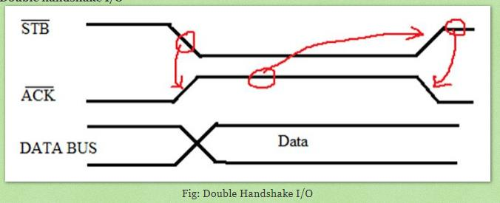

Explain the block diagram of 8255 PPI.
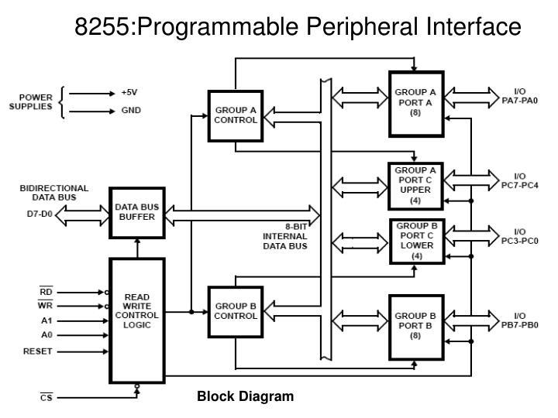
Figure shows the internal block diagram of 8255A. It consists of data bus buffer, control logic and Group A and Group B controls.
- Data Bus Buffer: This tri-state bi-directional buffer is used to interface the internal data lilts of 8255 to the system data bus. Input or Output instructions executed by the CPU either Read date from or Write data into the buffer. Output data from the CPU to the ports or control register, and input data to the CPU from the ports or status register are all passed through the buffer.
- Group A and Group B Controls: Each of the Group A and Group B control blocks receives control words from the CPU and issues appropriate commands to the ports associated with it. The Group A control block controls Port A and PC7-PC4 while the Group B control block controls Port B and PC3-PC0.
- Port A: This has an 8-bit latched and buffered output and an 8-bit input latch. It can be programmed in three modes: mode 0, mode 1 and mode 2.
- Port B: This has an 8-bit data I/O latch/ buffer and an 8-bit data input buffer. It can be programmed in mode 0 and mode 1.
- Port C: This has one 8-bit unlatched input buffer and an 8-bit output latch/buffer. Port C can be spitted into two parts and each can be used as control signals for ports A and B in the handshake mode. It can be programmed for bit set/reset operation.
- Read Write Control Logic:
• This is getting the input signals from control bus and Address bus
• Control signal are RD and WR.
• Address signals are A0, A1 and $\overline{CS}$.
• 8255 operation is enabled or disabled by $\overline{CS}$.
• RESET: This is used to reset the device. That means clear control registers.
Port Selection:
Address lines A0, A1 and Chip Select ($\overline{CS}$) used in various port selection as :
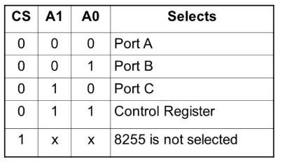

QNS: Explain different operating modes in 8255 PPI.
8255- PPI Modes of operation

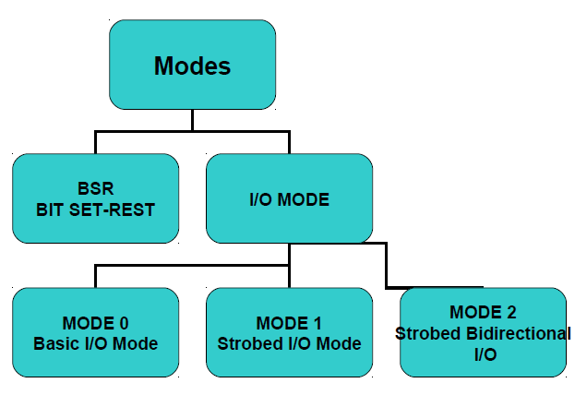

Remember: These modes are achieved in 8255 PPI by writing appropriate bits in the CONTROL REGISTER.

BIT Set Reset Mode (BSR Mode)
• The PORT C can be Set or Reset by sending OUT instruction to the CONTROL registers.
• The control word format for the BSR mode is shown.

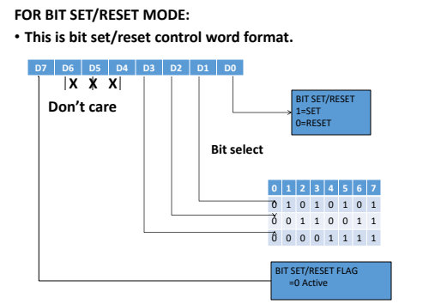

Input/output mode (I/O)
Feature | Mode 0 (Simple I/O) | Mode 1 (Strobed I/O) | Mode 2 (Bidirectional I/O)
Operation | Basic data transfer without any status check or synchronization. | Strobed data transfer where the peripheral and CPU "agree" when to send/receive. | High-speed bidirectional communication on a single 8-bit bus.
Input Status | Not Latched (Buffered only). | Latched (Internal register holds data until read). | Latched.
Output Status | Latched. | Latched. | Latched.
Handshaking | None used. | Used. Uses 3 pins of Port C per port (A or B). | Used. Uses 5 pins of Port C for Port A only.
Application | LEDs, simple switches, 7-segment displays. | Printers (Output), Keyboards (Input), A/D Converters. | Inter-CPU communication, Floppy Disk Controllers.
Interrupt | No. | Yes (Supports interrupt-driven I/O). | Yes (Supports interrupt-driven I/O).

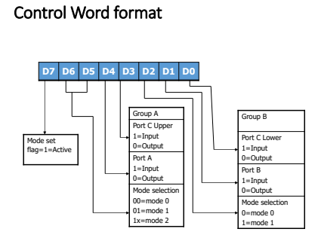

Next Serial Transmission:
A Serial Interface is used for transmitting a single bit at a time on a single channel.
Benefits: Homework
Drawback : Homework



Serial Communication
• Data transferred one bit at a time.
• Single wire used and low cost but slow in speed.
• Byte of data must be converted to serial bits using a parallel-in-serial- out shift register, then it can be transmitted over a single data lines.

Modes of Serial Transmission
- Synchronous Transmission
- Asynchronous Transmission
Differentiate between synchronous serial and asynchronous serial transmission.
Do it yourself.

8251 USART
8251 USART is a universal synchronous and asynchronous controller designed by Intel basically to facilitate communication.
Why USART ?
USART stands for Universal Synchronous and Asynchronous Receiver Transmitter and functions as an intermediary that allows serial and parallel communication between the microprocessor and the peripheral devices.
We know that microprocessors allow parallel communication. And in parallel communication, the number of cables required for data transmission is equal to the number of bits to be transmitted per cycle.
Thus the approach of transmitting data parallelly to long distance is cost-ineffective.
So, to reduce the overall cost of the system despite parallel data communication between the processor and peripheral devices, the serial transfer of data is permitted.
Hence for this purpose, USART acts as a mediator between the processor and peripheral devices so, that the parallel data from the processor can be converted into serial data and efficiently transferred to the peripheral devices.
In a similar way, the serial data from the peripheral devices is converted by the USART into the parallel form so that it can be accepted by the processor.
Also, it allows both synchronous and asynchronous transmission and reception thus is called so.

Architecture and Working of 8251 USART
The figure below shows the architectural representation of 8251:
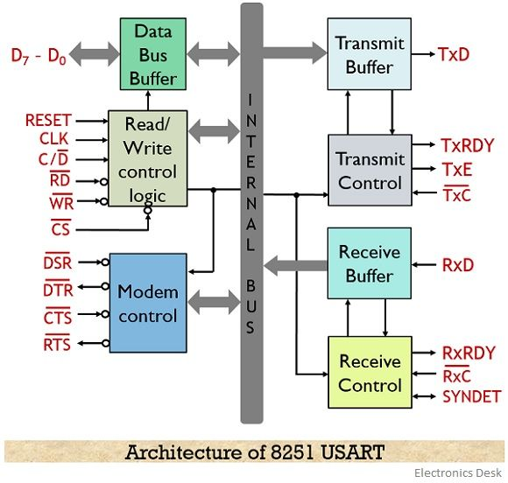
Let us now understand the operation performed by each unit in detail:
1. Data Bus Buffer: It basically interfaces the 8251 with the internal system buses of the processor.
The data bus buffer has 8-bit bidirectional data bus that allows the transfer of data bytes, status or command word between the processor and external devices.
2. Read/Write Control Logic: This functional unit generates a control signal for the operation of 8251 according to the signal present in the control bus of the processor. Basically, it performs decoding operation of the control signal produced by the processor, so that respective operation can be performed by the USART.
The control formats for system operation is stored in control and command word registers present in the read/write logic unit.
The signals handled by the read/write control logic unit are discussed below:
- CS: It is chip select. A low signal at this pin shows that processor has selected 8251 in order to communicate with the peripheral devices.
- C/D: As the system has control, status and data register. So, when a high signal is present at this pin then control or status register is addressed. While in case of low signal data register is addressed.
- RD and WR: Both read and write are active low signal pins. A low signal at RD shows that the processor is reading the control, status or data bytes from the 8251. While at WR indicates the write operation over the data bus of 8251.
- CLK and RESET: CLK stands for clock and it produces the internal timing for the device. While an active high signal at the RESET pin puts the 8251 in the idle mode.
3. Transmit Buffer: This unit is used to change the parallel data received from the CPU into serial data by inserting the necessary framing information. Once the data is transformed into serial form, then in order to transmit it to the external devices, it is provided to the TxD pin of the 8251.
This unit consists of 2 registers. These are as follows:
- Buffer register: Basically the data provided by the processor is stored in the buffer register. As we know that initially, the CPU provides parallel data to 8251. So, the processor loads the parallel data to the buffer register. Further, this data is fed to the output register.
- Output register: The parallel data from the buffer register is fed to the empty output register.
This register changes the 8-bit parallel data into a stream of serial bits. Then further the serial data is provided at the TxD pin so as to have its transfer to the peripheral device.
As we have already discussed that it performs both synchronous and asynchronous transmission and reception. Thus in case of asynchronous transmission, start and stop bit is added by the transmitter in order to notify the external devices about the data transmission.
But in case of synchronous transmission, the clock signal is used thus there exists no need of adding additional bits expect the parity bit (if required).
4. Transmit Control: As the name of the unit is itself indicating that it is controlling the transmission action. And it does so by accepting and sending signals both externally and internally.
The various control signal generated by this unit are as given below:
- TxRDY: It implies transmit ready. This signal is used to notify the processor that the buffer register of the 8251 is empty and ready to accept the data.
The status read operation is utilized by the processor in order to check the presence of the signal.
- TxE: This stands for transmitter empty. It is an active high signal that indicates that the output buffer is empty and thus data received from the processor can be loaded to it for conversion.
- TxC: It stands for transmitter clock and is an active low pin. It controls the rate of character transmission by the USART.
However, 8251 offers programmable clock rate. As by writing appropriate mode word in the mode set register the clock division can be programmed.
5. Receive Buffer: This unit takes the serial data from the external devices, changes the serial data into the parallel form so that it can be accepted by the processor. It consists of 2 registers: receiver input register and buffer register.
When the external device is ready to send the data to the 8251 then it sends a low signal to the RxD line of the 8251. In asynchronous mode, once 8251 receives a low signal it considers that signal as start bit of the data.
So, once the start bit is successfully accepted by 8251, then it also receives the whole data bits in serial form along with parity and stop bits.
Once the data is received by the receiver input register then it converts the data bits in parallel form and sends it to the receiver buffer register.
In case of the synchronous mode of operation, according to the clock input, the external device loads the serial data bits in the receiver input register. And on converting the serial data to parallel format the receiver input register sends the data to the buffer register.
6. Receiver Control
This unit controls the operation of the receiver buffer. It manages the data reception, along with that it also detects the presence of false start bit, error in parity bit, framing errors etc.
- RxRDY: It stands for receiver ready. When this signal goes high then it indicates that the receiver buffer register is holding the data and is ready to transfer it to the processor. Once the CPU reads the data sent by the 8251 then this pin is reset.
- RxC: It stands for receiver clock. This clock signalling controls the rate at which the 8251 receives the data in the synchronous mode of operation. It is provided by the modem and is equal to the baud rate.
While asynchronous mode offers the clock rate as 1, 16 or 64 times of the baud rate as it is programmable.
7. Modem Control: This unit of 8251 holds input and output control signals that simplify the operation of the whole system. The control circuitry for handing various signals is provided by the modem control unit. It includes DTS, RTS, DTR and CTS.
These are all active low signals.
- DSR: Stands for data set ready and the signal is used to check whether the data set is ready or not when the processor is in the urge of communication.
- DTR: Implies data terminal ready. An active-low signal at this pin shows that the 8251 is now ready to accept the data from the processor.
- RTS: It stands for the request to send. A low signal shows an assertion for data transmission.
- CTS: Clear to send. When 8251 receives a low signal at this pin then it clears all the data present in the modem in order to allow further communication.

